Egg Forms
Human cultures have revered ovoid forms for millennia, associating them with fertility and renewal. Human makers have adopted ovoid forms in their art using wood, glass, metal of all sorts, ceramics, textiles, and stone. Ovoid shapes appear in Paleolithic Era cave paintings, and the roots of Ukrainian egg dying go back more than 5,000 years.
In engineering terms, ovoid forms have an incredible strength-to-weight ratio under compression. As long as one keeps the pressure evenly distributed, it requires considerable strength to crush an egg by squeezing it in your hand. When engineers want to design lightweight hydro-dams, tanks, and pressure vessels, ovoids usually come up. Ovoid forms do not typically roll in a straight line, making them ideal in situations where rolling away from the center of the nest can be problematic.
Egg forms occur throughout the natural world, so it is only fitting that anyone with access to a lathe should learn how to turn them, in fact, egg forms make excellent practice exercises for honing one’s tool handling and observational skills.

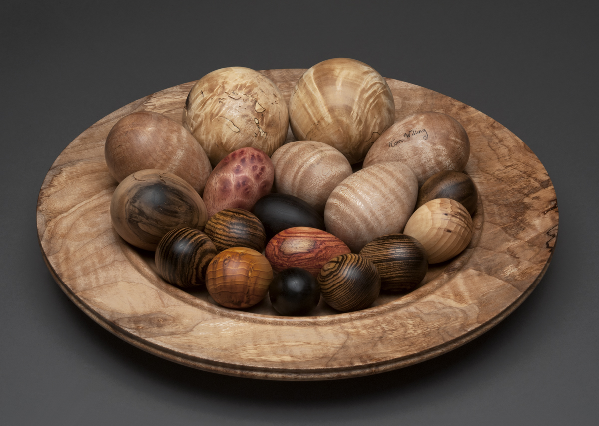
Photography by Loren Nelson

